COP 4710 – Exam #1 – Fall 2013

NAME:

September 24, 2013 (100 points)

KEY

1. (20 points – 2 points each)
Provide answers to questions (a)-(j) based on the scenario shown in the ERD diagram below.

- Is every employee either a staff member, administrator, or professor?
NO

- Does every course generate a class?
NO

- Can any employee chair a department?
NO, only professors

- Can a professor be employed by more than one department?
NO

- Do professors have a hire date?
YES, inherited from EMPLOYEE

- Is every class generated by a course?
YES

- Is every room used for a class?
NO

- Does every department offer a course?
NO

- Can an employee be both a staff member as well as an administrator?
YES

- Does every school have a dean?
NO
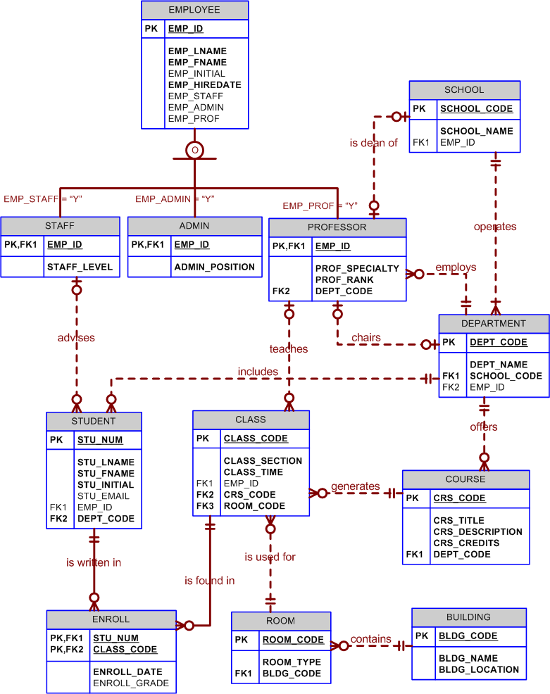

2. (15 points – 5 points each)
We discussed how cardinality constraints in an ER diagram can affect the placement of an attribute. For the two scenarios shown below answer each question.

(a) A person works on possibly many different projects, but a project has only one person who works on that project. For each person working on a project we want to record the date that they worked on the project. Which of the following ERDs is correct for this scenario? Justify your answer.
name
department
date
person
projectid
budget
project
name
department

person
projectid
budget
date
project

(a) (b)

The correct ERD is (b). Since a person can work on more than one project, placing the date attribute in the person entity will allow us to model only a single date.

(b) A person files a report and each report is filed by only one person. Each person must file a report and every report is filed by a person. For each report filed we want to record the date that the report was filed. Which of the following ERDs is correct for this scenario? Justify your answer.

name
date
person
reportid
length
subject
report
person
report

name

reportid
length
subject
date

(a) (b)

Either ERD is correct. Since the cardinality constraint is 1:1 the date could belong to either the person or the report. Logically it probably makes more sense to associate the date with the report, but from a functional point of view, either one is ok.

(c) A bicycle racer competes in possibly many different races. Races (events) have many different riders competing in the event. For each rider competing in an event we want to record their finishing position in the race. Which of the following ERDs is correct for this scenario? Justify your answer.
name
class
finish-position
riders
racename
distance
field-size
races
name
class
riders
racename
distance
field-size
finish-position
races

(a) (b)

Neither ERD is correct. ERD (a) is not correct because it implies that a rider can have only one finishing position. ERD (b) is not correct because it implies that a given race can have only one finishing position.

3. (30 points)
Using the conversion rules we discussed in class, convert the E-R diagram shown below into a set of relation schemas. Be sure to include referential integrity constraints. Use the next page for your answer.

flies/flown-by
flies/flown-by
Aircraft
plane-name
date-built
hours-flown
Pilots
pilot-name
years-flown
age
date-last-flight
Commerical
num-seats
fuel-capacity
num-engines
{flight-schedule}
Military
altitude-limit
num-weapons
stealth?
Recreational
FAA-num
weight-limit
o
Combat-Mission
op-name
location
num-targets
date

Aircraft
plane-name
date-built
hours-flown
c?
m?
r?
Commerical
c-plane-name
num-seats
fuel-cap
num-engines
Flight-Schedule
c-plane-name
flight
Military
m-plane-name
altitude-limit
#weapons
stealth?
Recreational
r-plane-name
FAA number
weight-limit limitapons
Combat Mission
op-name
num-targets
location
m-plane-name
date
Pilot
pilot-id
years-flown
age
Flies
pilot-id
date-last-flown
plane_name
Solution Page For Problem 3

4. (35 points)
“Martial Arts R Us” (MARU) needs a database. MARU is a martial arts school with hundreds of students. It is necessary to keep track of all the different classes that are being offered, who is assigned to teach each class, and which students attend each class. Also, it is important to track the progress of each student as they advance. Create a complete Crow’s Foot ERD for these requirements:

- Students are given a student number when they join the school. This is stored along with their name, date of birth, and the date they joined the school.
- All instructors are also students, but clearly, not all students are instructors. In addition to the normal student information, for each instructor, the date that they start working as an instructor must be recorded, along with their instructor status (compensated or volunteer).
- An instructor may be assigned to teach any number of classes, but each class has one and only one assigned instructor. Some instructors, especially volunteer instructors, may not be assigned to any class.
- A class is offered for a specific level at a specific time, day of the week, and location.
- Students may attend any class of the appropriate level during each week so there is no expectation that any particular student will attend any particular class session. Therefore, the actual attendance of students at each individual class meeting must be tracked.
- A student will attend many different class meetings; and each class meeting is normally attended by many students. Some class meetings may have no students show up for that meeting. New students may not have attended any class meetings yet.
- At any given meeting of a class, instructors other than the assigned instructor may show up to help. Therefore, a given class meeting may have several instructors (a head instructor and many assistant instructors), but it will always have at least the one instructor that is assigned to that class. For each class meeting, the date that the class was taught and the instructors’ roles (head instructor or assistant instructor) need to be recorded. For example, Mr. Cehnes is assigned to teach the Monday, 5:00 pm, intermediate class in Room #1. During one particular meeting of that class, Mr. Cehnes was present as the head instructor and Ms. Jones came to help as an assistant instructor.
- Each student holds a rank in the martial arts. The rank name, belt color, and rank requirements are stored. Each rank will have numerous rank requirements. Each requirement is considered a requirement just for the rank at which the requirement is introduced. Every requirement is associated with a particular rank. All ranks except white belt have at least one requirement.
- A given rank may be held by many students. While it is customary to think of a student as having a single rank, it is necessary to track each student’s progress through the ranks. Therefore, every rank that a student attains is kept in the system. New students joining the school are automatically given a white belt rank. All ranks have at least one student that has achieved that rank at some time.

Solution

